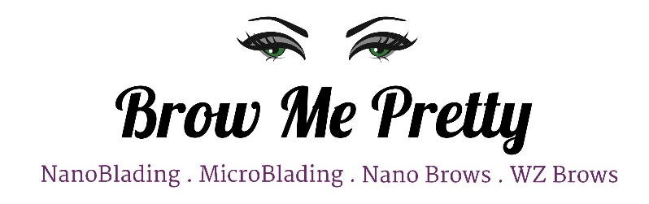

Firm Business Terms & Policies

- A nonrefundable $200 deposit is required to schedule and secure your Semi-permanent procedure. The amount will be deducted from the total cost of your service on the day of your appointment. It is strongly advised to schedule a FREE consultation prior to scheduling your procedure. Skipping on scheduling a consultation could result in a full deposit loss if found not a good candidate for the procedure on the day of the appointment.
- Your consideration and respect for our schedule is greatly appreciated, please notify us in advance and give us a 72-hour rescheduling notice. Keep in mind we block on average 3 1/2 hours of the schedule for the service. A one-time appointment rescheduling is allowed and free of charge, 2nd rescheduling request will result in a $50 fee. 3rd rescheduling requests the client will lose the deposit and will be charged a new deposit if the client wishes to remain on the schedule. 4th rescheduling request will not be granted, strictly final. Rescheduling requests on the same day of the procedure at such very short notice leads to deposit loss or the choice to pay the full amount of the procedure to get rescheduled.
- Required initial touch-up should be scheduled 6-8 weeks from the day of the procedure to complete and perfect micro-pigmented brows. Additional charges may apply if scheduled after the 12-week mark unless discussed and planned in advance. Any refund request will not be granted if the client chooses not to continue with the required process of the procedure.
- No family members or friends are allowed in the procedure room unless the client is minor or requires physical help due to medical reasons.
- New clients who had any form of brow tattooing done by another artist MUST schedule a consultation appointment first to determine whether a touch-up or correction is needed.
- NO call NO show will firmly NOT be granted another appointment on our schedule.

Once you're a client you're automatically enrolled in our BMP Rewards Program. With every client referral a $25 will be applied towards the cost of your Brow Me Pretty Annual Touch Up (Regularly $375).

